**Pedal Box Design Concepts 24/04-1/05**

-Horizontally mounting Master Cylinders (in front of the brake pedal)

-ASB Actuator local to master cylinder mounting

-Creating a false floor + extending pedal shafts for adequate piston mounting points

Travel Figures

-Current Shaft Travel (w Master Cylinders) ~ 60mm

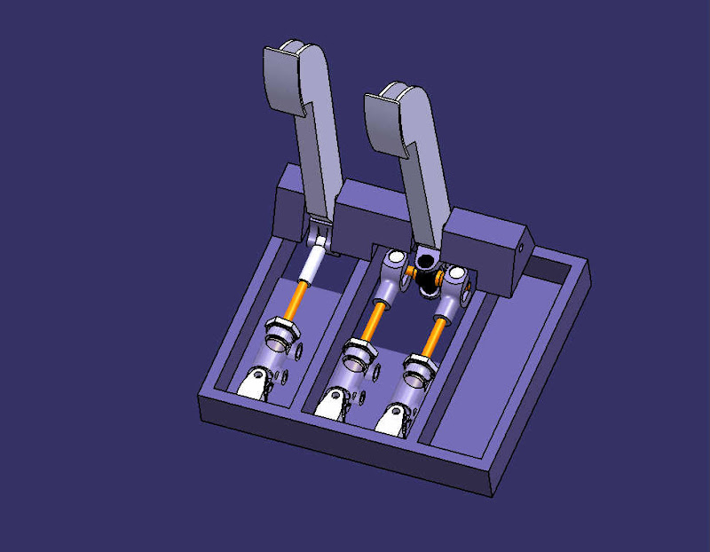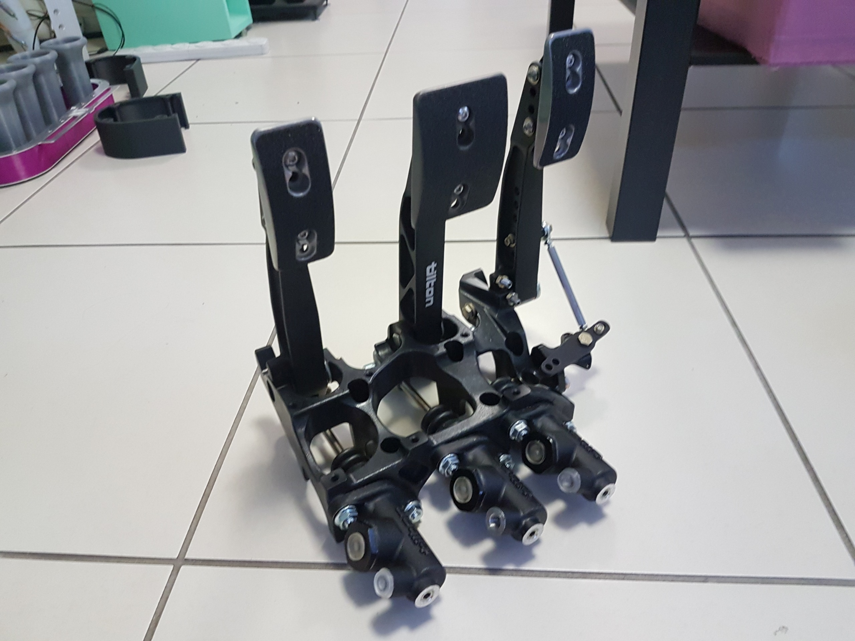

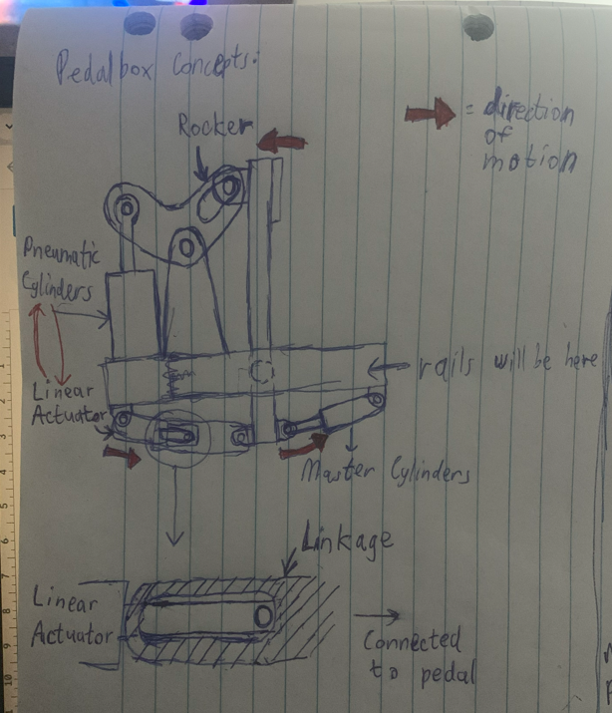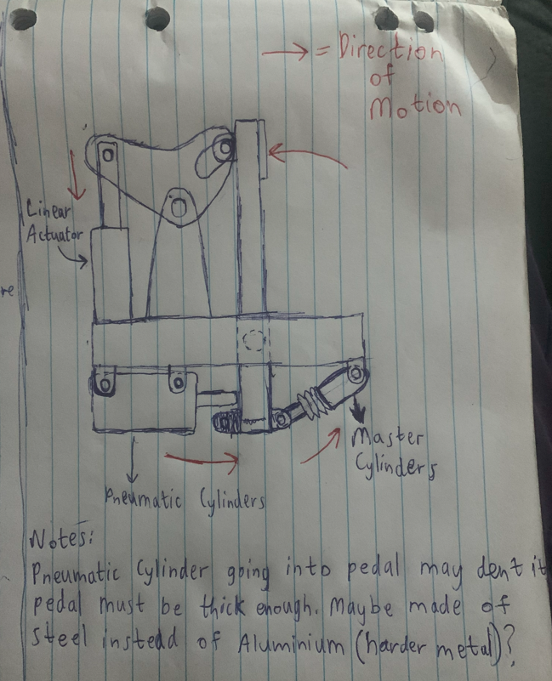

**Iteration 1 Iteration 2**

**Pneumatic Cylinder above Linear Actuator above floor**

**floor**

[reverse type pedal box -2.pdf](https://studentutsedu-my.sharepoint.com/:b:/g/personal/adesh_grewal_student_uts_edu_au/EcmPDgsG-FJNkZrf1nKmAEYB2xlnD_VQ3KVk_V-MWi4_ew?e=kx8en1)

**Master Cylinder Specs**

Master cylinder stroke is = 30 mm.  
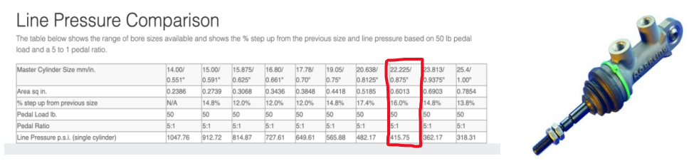

<https://apracing.com/race-car/master-cylinders/line-pressure-comparison>

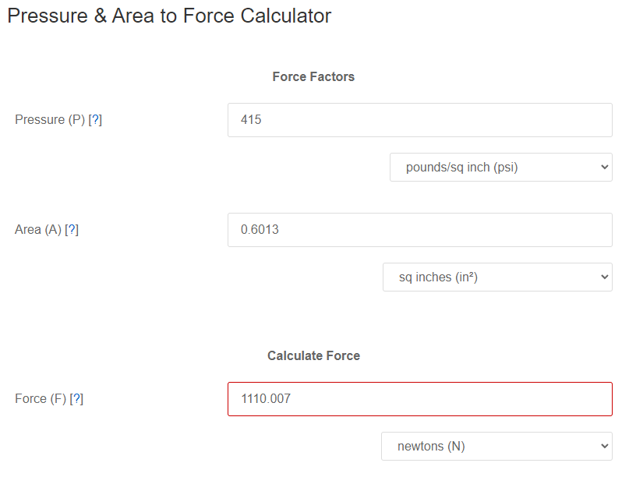

1.1kN required to compress a single master cylinder, hence EBS pneumatic cylinder should be rated for 2.2kN+ per cylinder (one should be strong enough to compress both)

**Master Cylinder max stroke length**

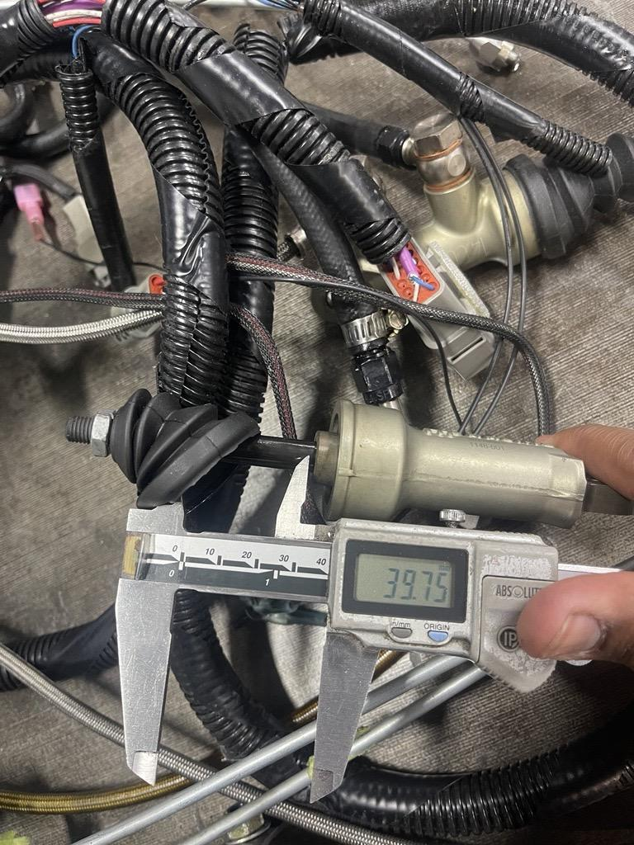

Pneumatic Cylinder Stroke stroke should be no greater than 40mm (if acting in parallel with master cylinders)

1. **Proposed Linear Actual (ASB)**

[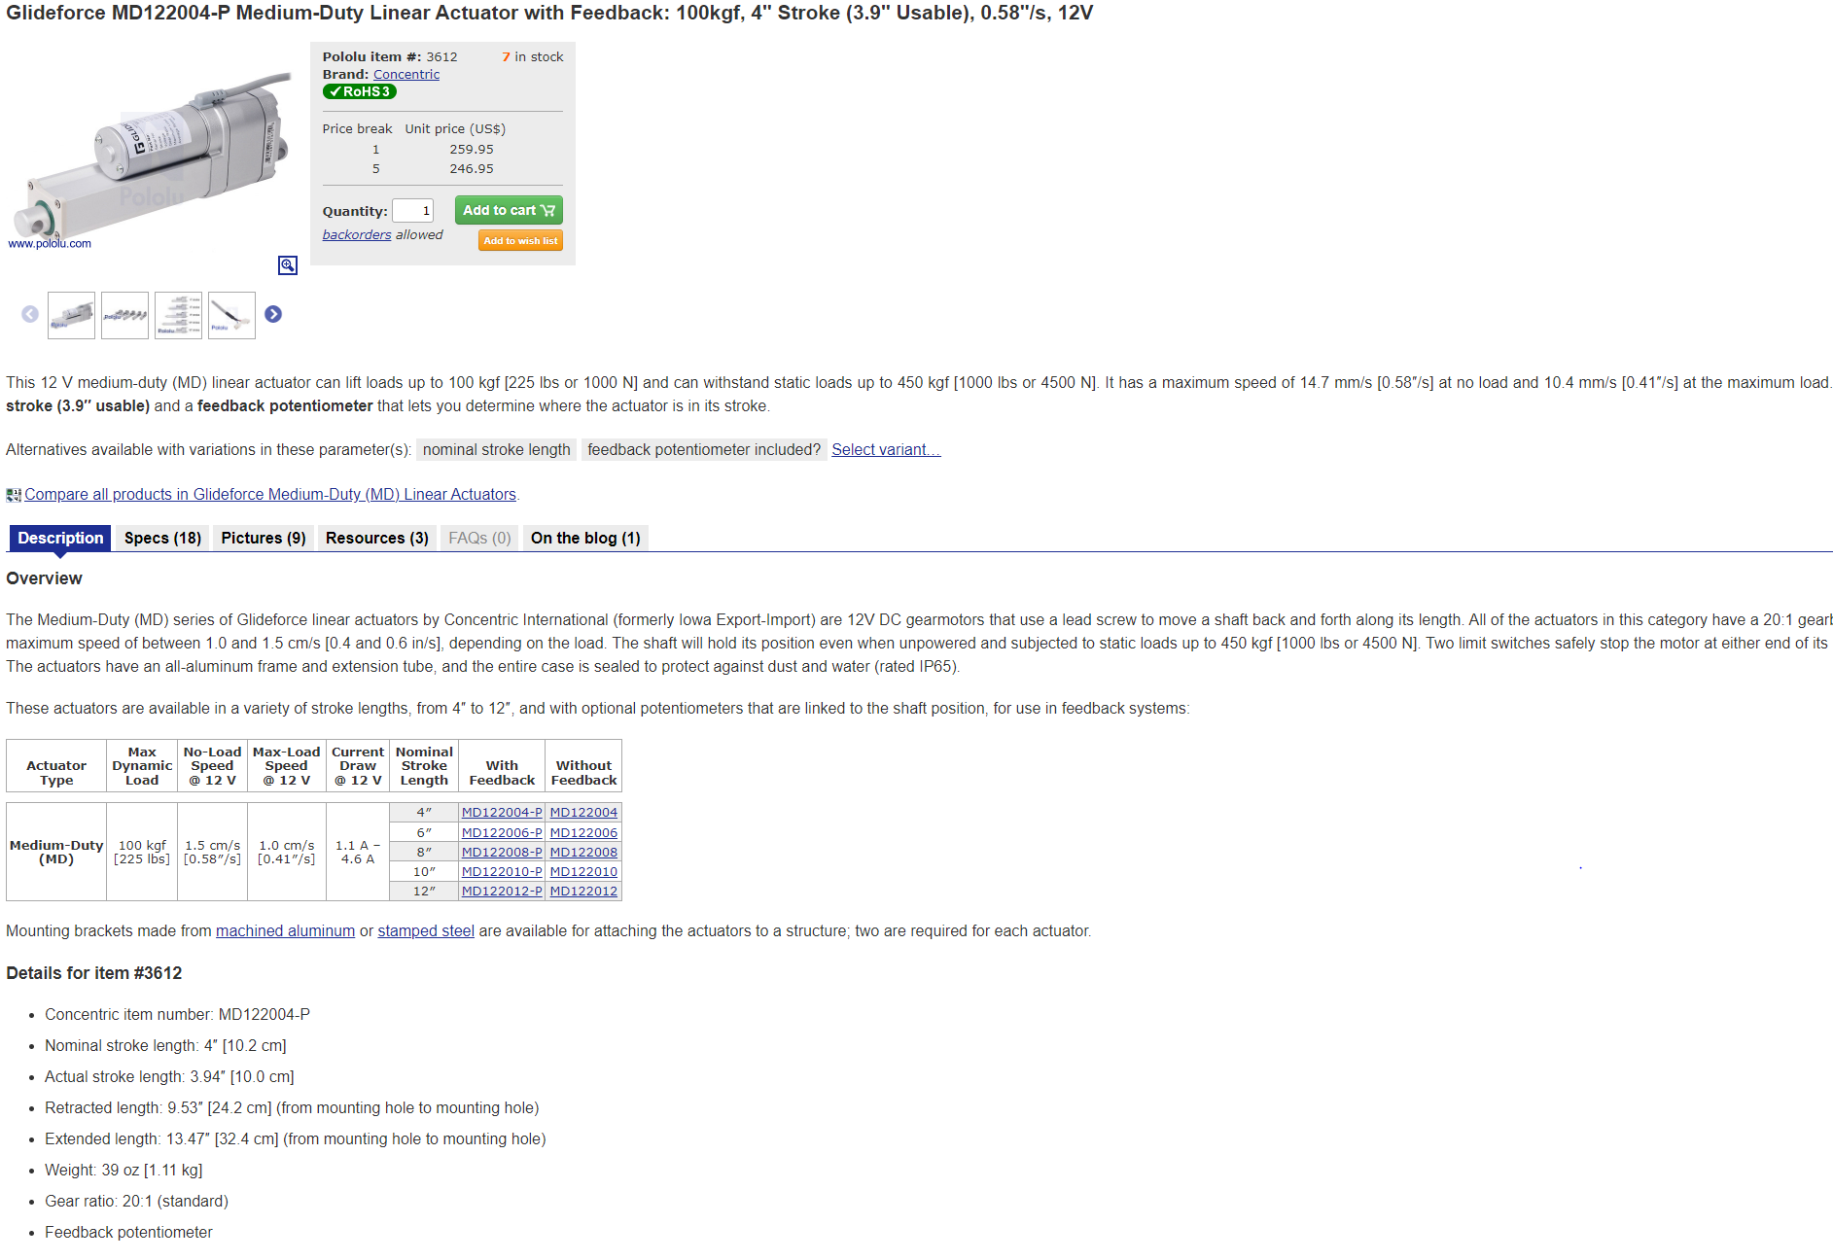](https://www.pololu.com/product/3612)  
<https://www.pololu.com/product/3612>

1. Proposed linear Actuator (ASB) Preferred and already available

[Electrak_HD_Actuator_bren-1.pdf](https://studentutsedu-my.sharepoint.com/:b:/g/personal/adesh_grewal_student_uts_edu_au/EdeIVV0igqFIq1gluwfFQsYBDY1ItbN2PgM7msUbmauZvQ?e=2EWbLg)

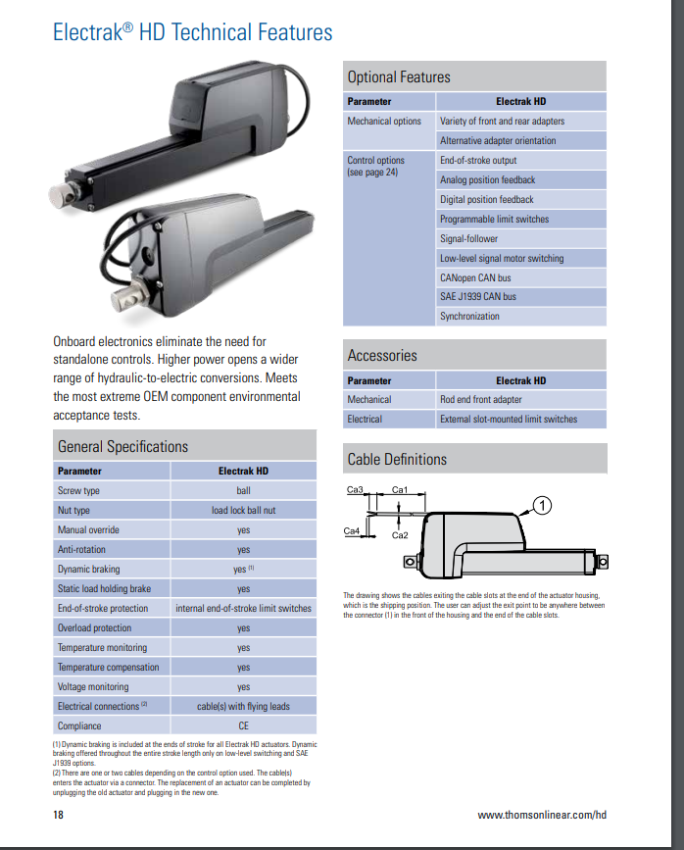

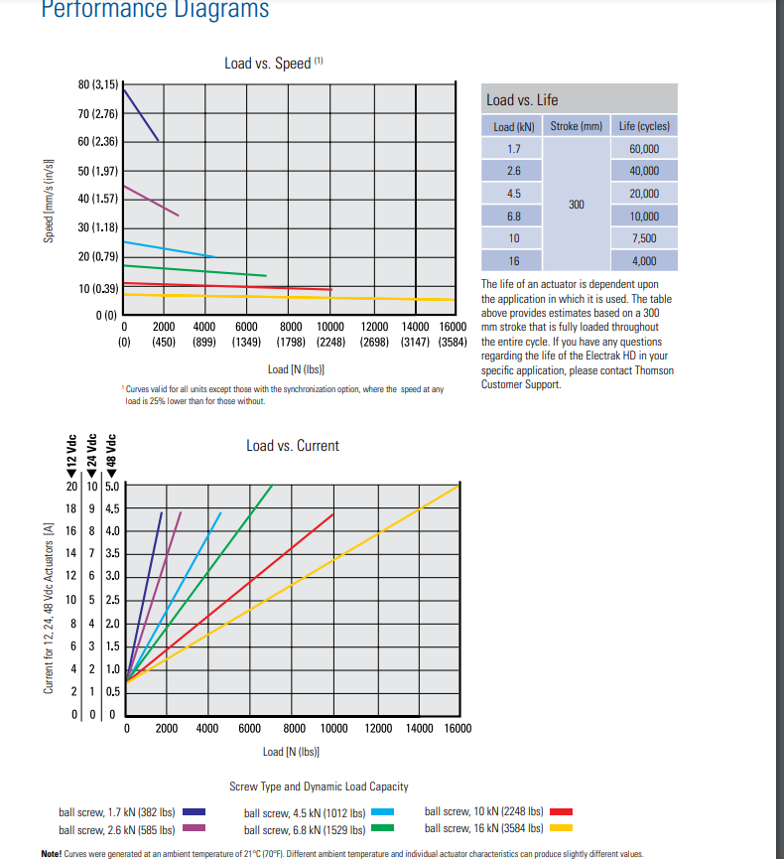

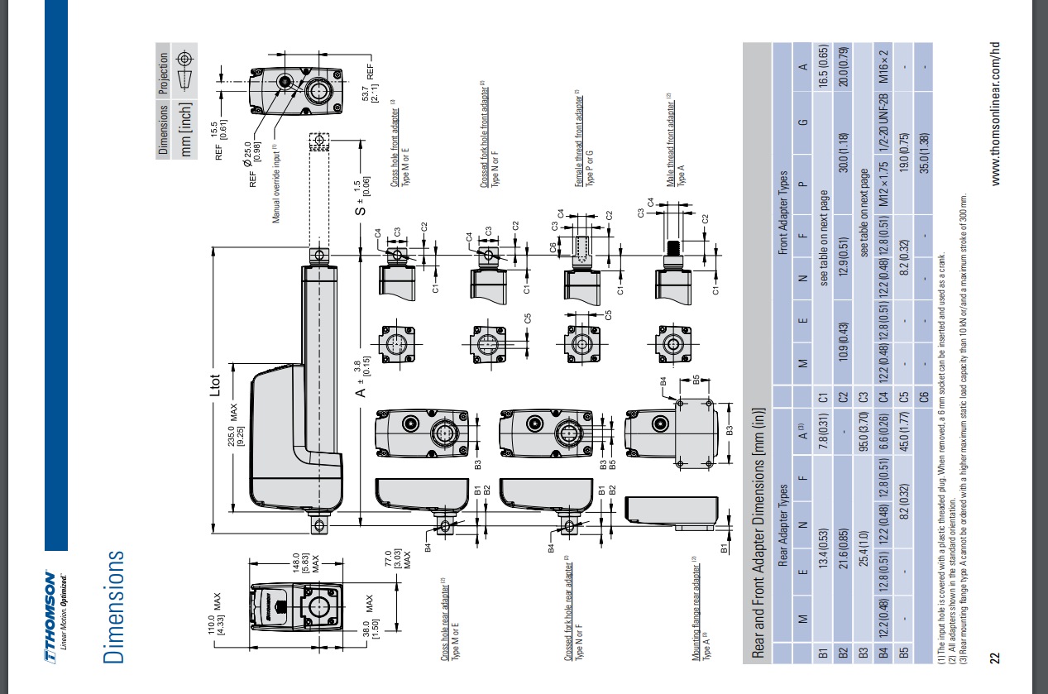

* **Brake Callipers**

<https://www.wilwood.com/calipers/caliperprod?itemno=120-8373>

**Proposed EBS Cylinders (EBS)   
  
- Current Cylinders (in workshop)**

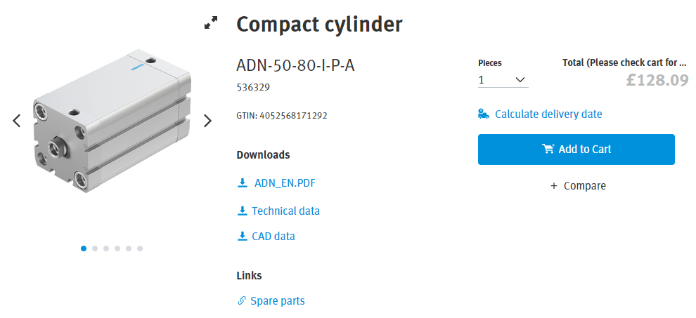

<https://www.festo.com/gb/en/a/536329/?jumpToAnchor=true>  
  
**- Proposed Compact EBS Cylinders**

1. SMC CQ2B50

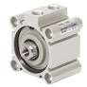

SMC compact cylinder CQ2B50 7531233

* Half stroke (40mm vs 80mm ^^^)

(<https://au.rs-online.com/web/p/pneumatic-piston-rod-cylinders/7531233>) [SITE BROKEN] - fixed  
  
<https://www.smcpneumatics.com/CQ2B50-50DMZ.html>

<https://www.smcpneumatics.com/pdfs/CQ2_Z.pdf>

* Stroke length seems fine at 40mm but force output per cylinder @ 0.7MPa is 1370N per cylinder, not suitable to act on both cylinders if one fails

1. **SMC CDQ2WB50TF-75DZ**

**-Specs titled on RS website seem wrong, 75mm bore cylinders don’t exist in data sheet**

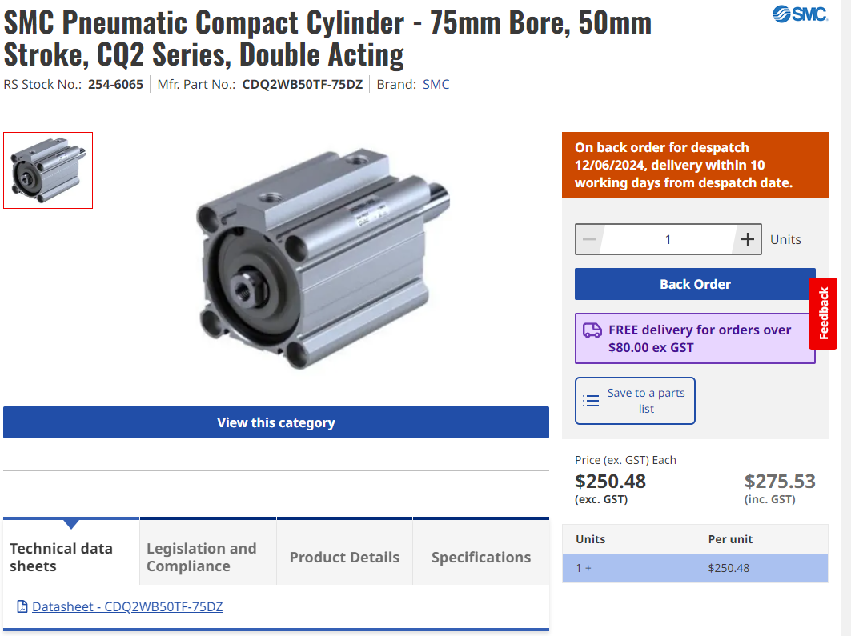

<https://au.rs-online.com/web/p/pneumatic-piston-rod-cylinders/2546065?gb=s>

**3)**

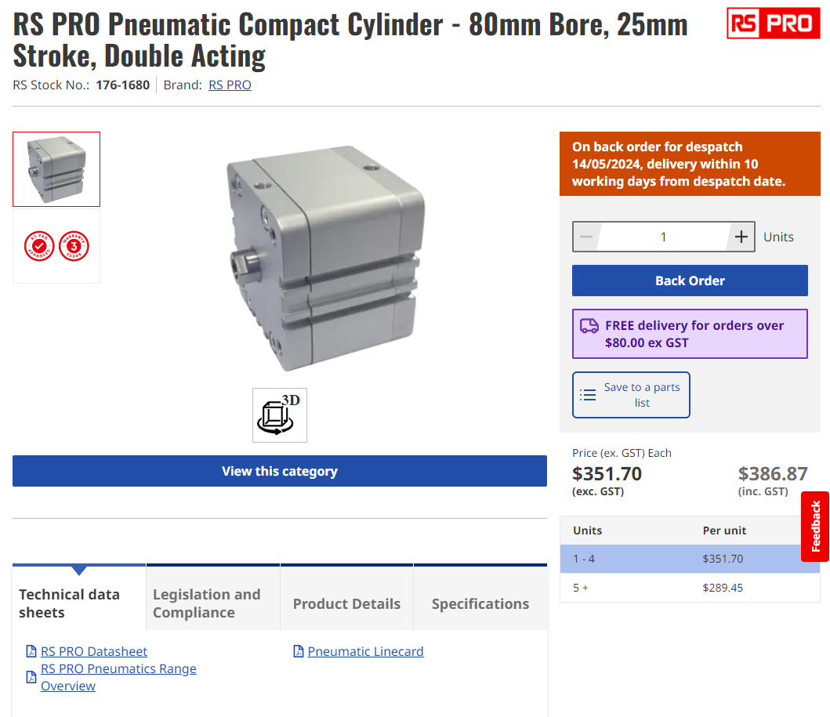[**https://au.rs-online.com/web/p/pneumatic-piston-rod-cylinders/1761680**](https://au.rs-online.com/web/p/pneumatic-piston-rod-cylinders/1761680)

* Suitable Bore (80mm), max operating pressure 1MPa
* 2700N @ 0.6MPa force and 3150N @ 0.7MPa (benchmark)
* Stroke is less than 40mm, but could it be too short? ~25mm
* Lead time seems fine

**4)**

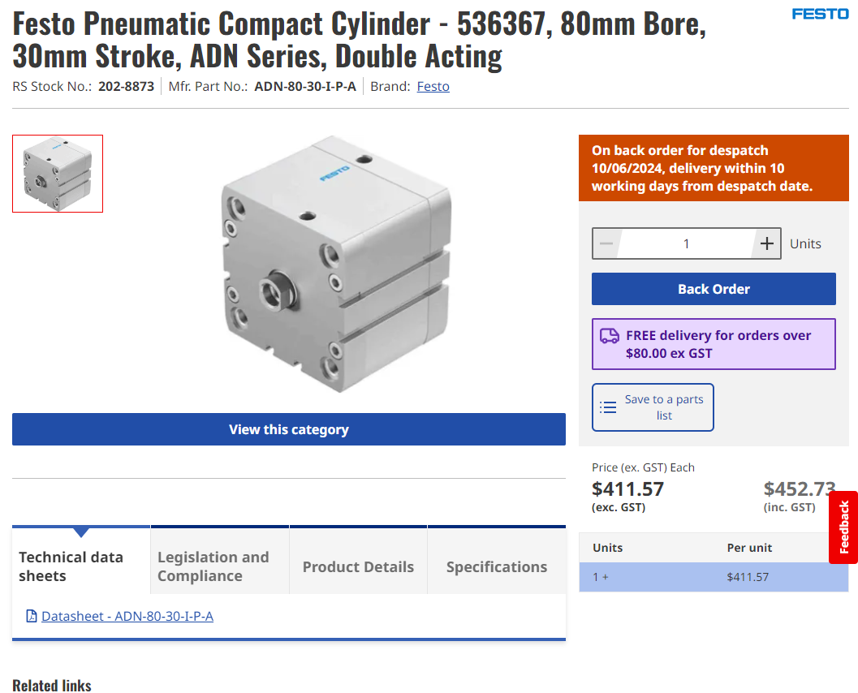

[**https://au.rs-online.com/web/p/pneumatic-piston-rod-cylinders/2028873**](https://au.rs-online.com/web/p/pneumatic-piston-rod-cylinders/2028873)

Dimensions and more info if needed: <https://www.festo.com/media/pim/744/D15000100121744.PDF>

* Similar to cylinder above
* More suitable stroke length ~ 30mm
* Output force slightly greater, can run at lower pressure (3016N @ 0.6MPa)
* Slightly longer lead times
* More expensive

Mounting option

**Existing Pressure Regulator**

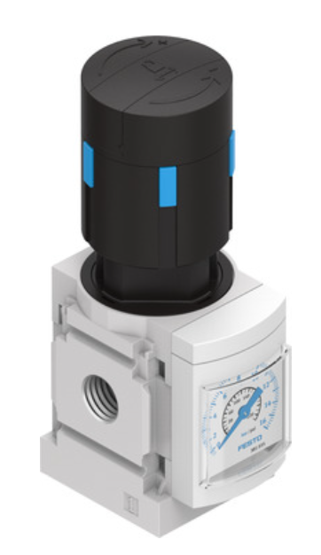

FESTO | MS4-LR-1/8-D7-AS

<https://www.festo.com/us/en/a/529425/?q=MS4-LR-1%2F8-D7-AS%7E%3AfestoSortOrderScored>

**Existing Solenoid**

FESTO | VUVG-LK10-M52-AT-M5-1H2L-S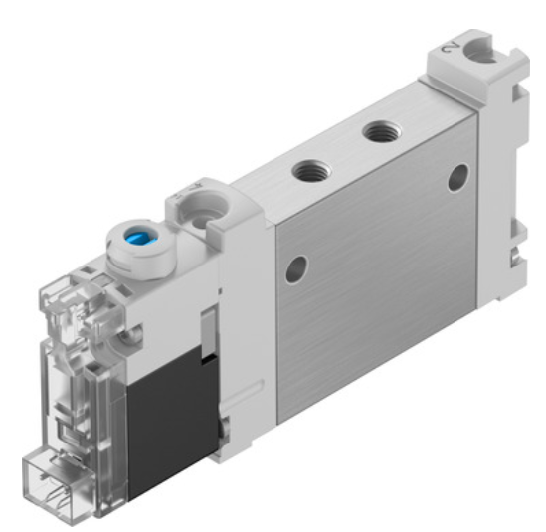

<https://www.festo.com/au/en/a/8042539/?fwacid=eadf3ee2e8e8f896&gad_source=1>

**Proposed Design Pedal Box**

chrome-extension://efaidnbmnnnibpcajpcglclefindmkaj/<https://www.racerindustries.com.au/assets/files/72-618-install-dwg_19.pdf>

**Current Chassis Photos**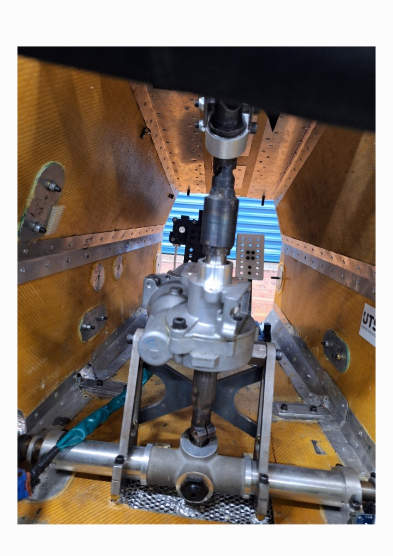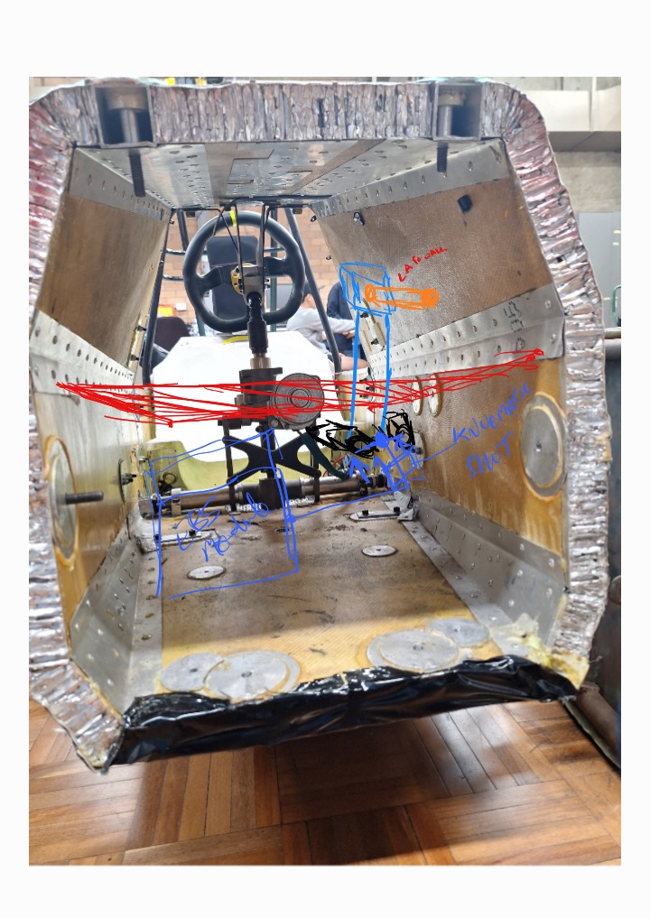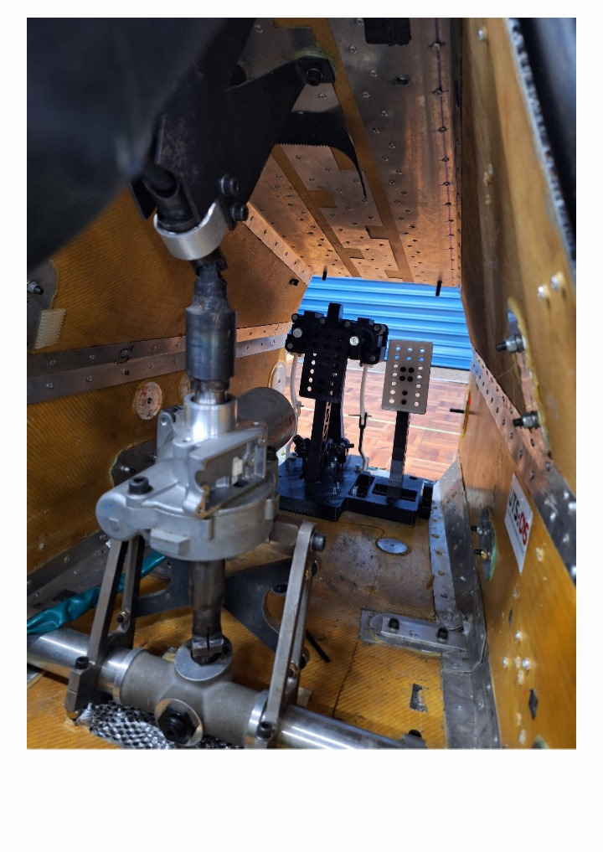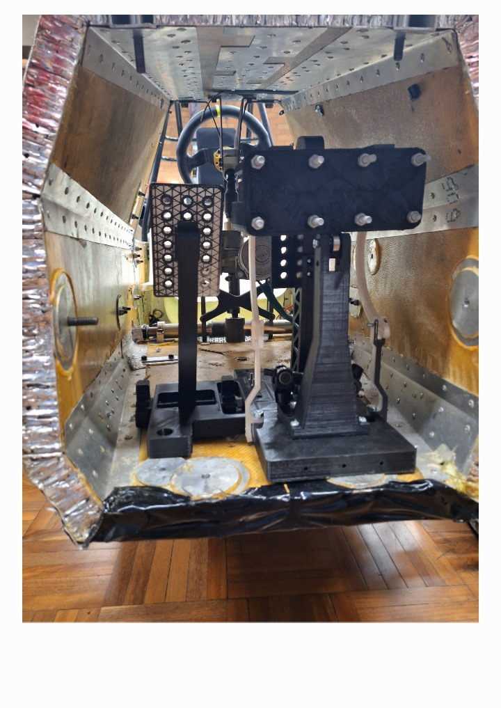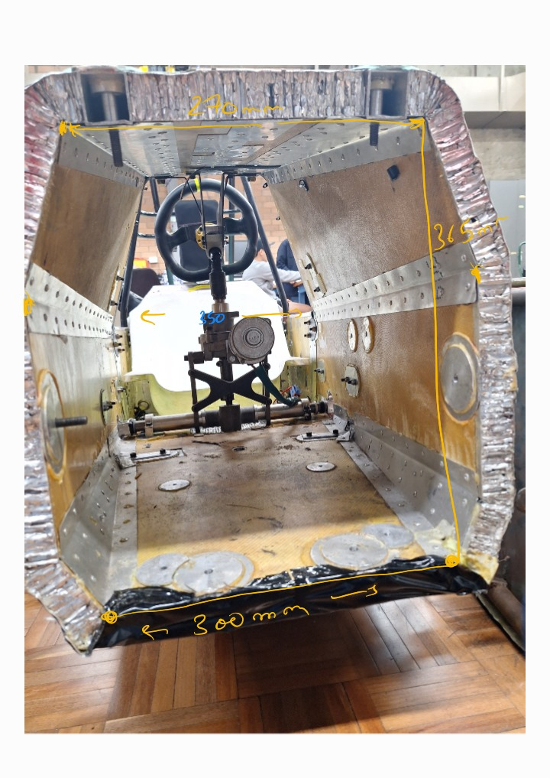

**CAD:**

**2023 PedalBox**

[**UTSME2023**](https://studentutsedu-my.sharepoint.com/:f:/g/personal/cheru_dassanayake_student_uts_edu_au/EknCV1w1MzdAjBhFxJeELAkBJeKFW3cbgO_IKXgngtdwFg?e=ap3hZN)

**Master Cylinders**

[**2019 vehicle dynamics_brakes_pedalbox_CP7855 AP Racing Master Cylinder-dg.SLDPRT**](https://studentutsedu-my.sharepoint.com/:u:/g/personal/cheru_dassanayake_student_uts_edu_au/Eabs3ihGt3ZKgXBR_mYBikwBcvykQCljfgmVEj5-bM6GGQ?e=FU8t6Y)

**Linear Actuator**

[Glideforce Linear Actuator](https://studentutsedu-my.sharepoint.com/:f:/g/personal/cheru_dassanayake_student_uts_edu_au/EqmExUTGhIBLqJsVMreJE44B3eOJhuP-fGwNhAMFpLNDVw?e=QaTTOD)

[Thompson ElectrakHD HD12B026-0100CNO2MMS](https://www.thomsonlinear.com/en/product/HD12B026-0100CNO2MMS)

* 12VDC
* 20A (3A/18A)
* 2600N
* Weight = 6.5kg
* Linear speed = 32mm/s (likelihood of being able to take it apart and change gear ratio for speed?)

**EBS Cylinders**

**Current Cylinder (In workshop)**[**Festo Pneumatic piston**](https://studentutsedu-my.sharepoint.com/:f:/g/personal/cheru_dassanayake_student_uts_edu_au/Eq7pXODupcVOhuglJedmwA8B9L65eTqQToa_qaoXIf7IJQ?e=kvqZk9)

**Proposed Cylinder**

[**Compact EBS Cylinder**](https://studentutsedu-my.sharepoint.com/:f:/g/personal/cheru_dassanayake_student_uts_edu_au/EsskOFr1gQxPrHlCfPYoQaYBLcYnBH37V43RdAHFEq42TQ?e=IG8QhS)

Motorsports CAD of braking system and more.

[**Motor**](https://studentutsedu-my.sharepoint.com/:f:/g/personal/adesh_grewal_student_uts_edu_au/EjS-KKgaYRFGo5kIhLhNwikBK9wnlx1bycJKemFuv9ePfA?e=J7gyB4)

**Outer shell for the pedal box.**It is slightly more constrained than the chassis, at most 5mm.

[Outer shell for brake pedal_24.SLDPRT](https://studentutsedu-my.sharepoint.com/:u:/g/personal/adesh_grewal_student_uts_edu_au/EYKb3djdDF9DktYGnfBrvoABeC5inKVakBFaW5EvHi5zOA?e=4fjc56)

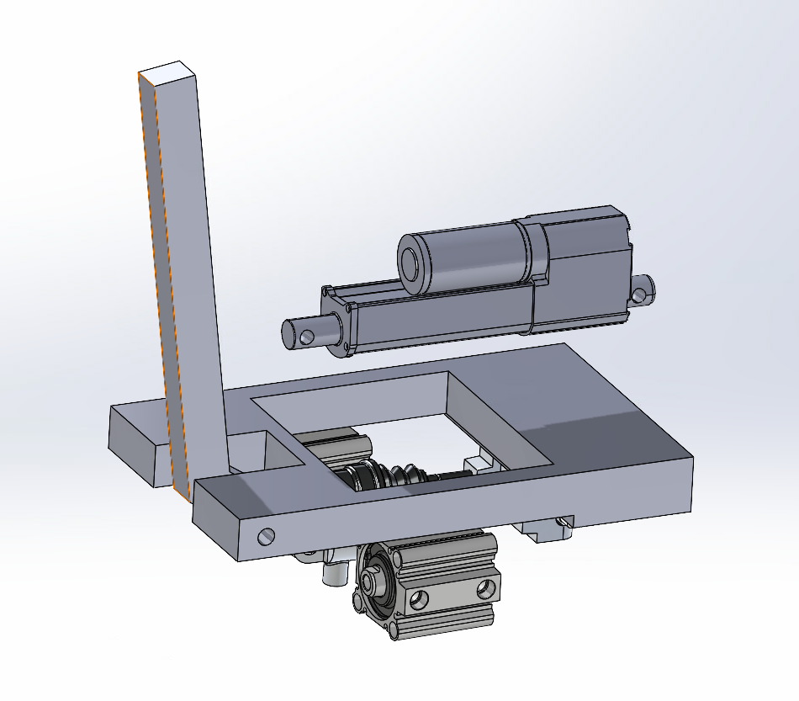

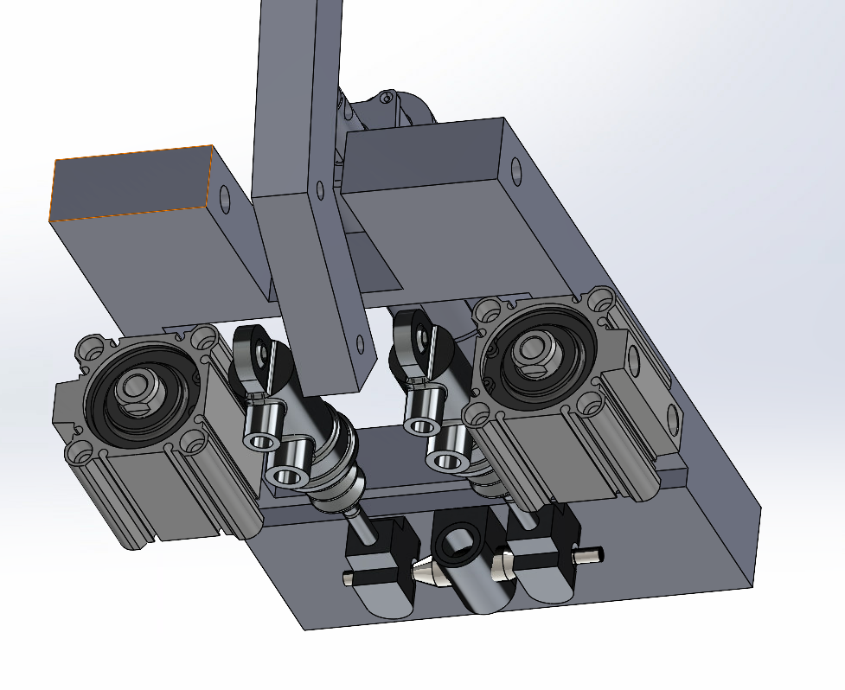

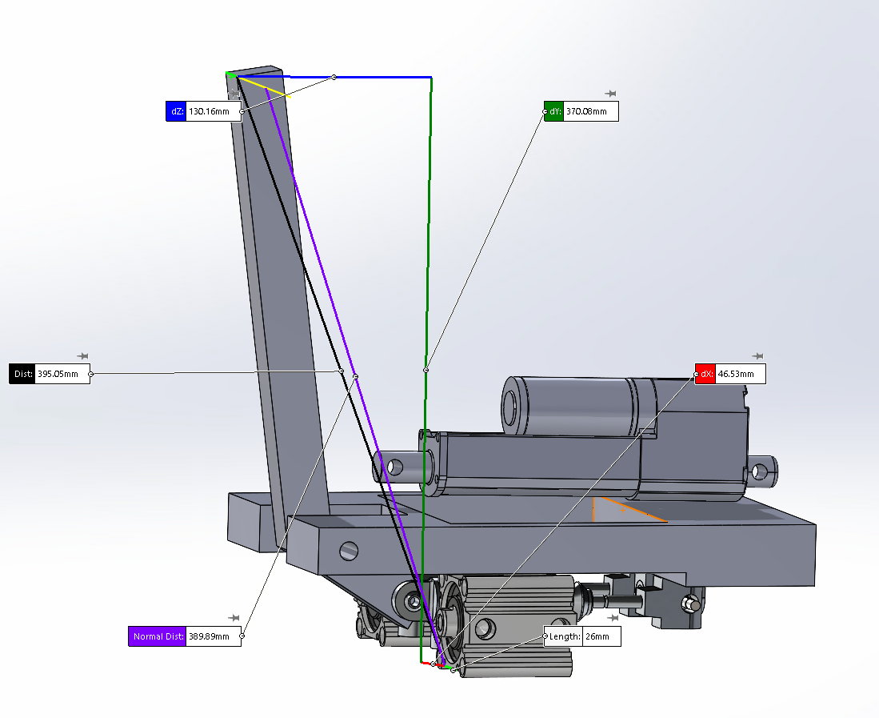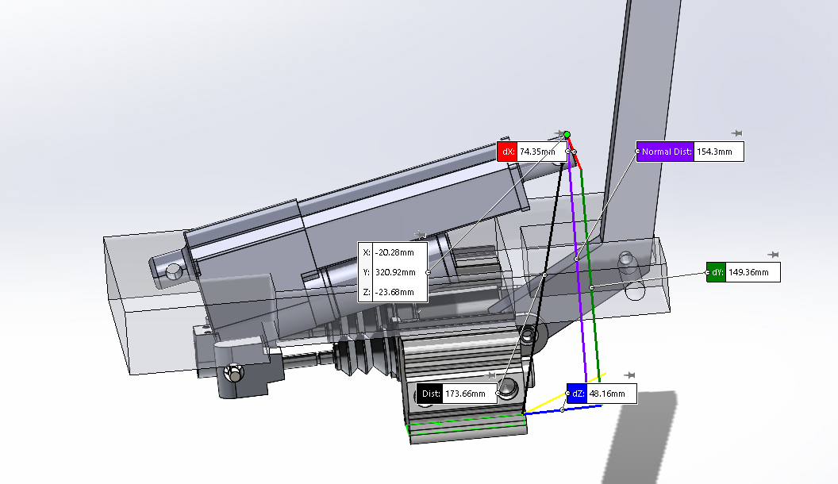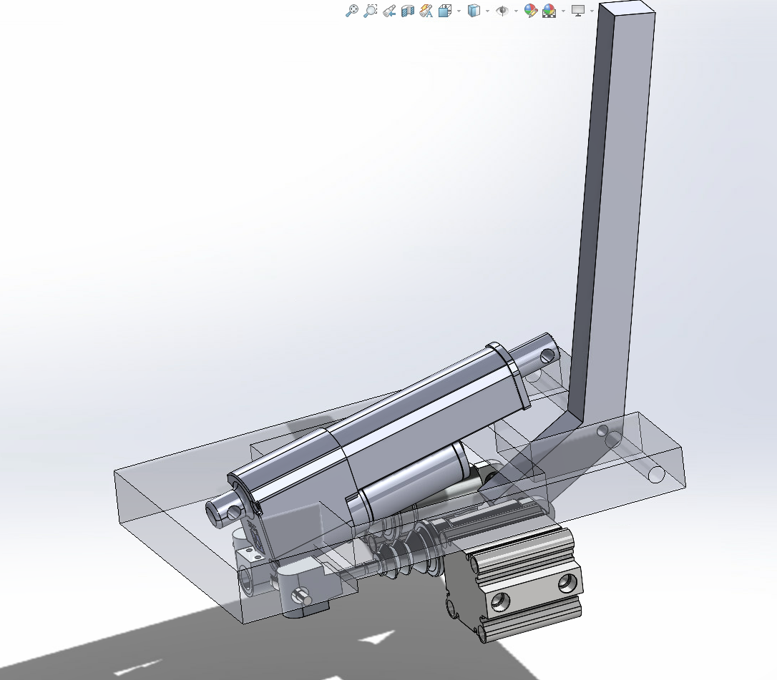

-ASB Actuator would need to be mounted at an angle; mounting vertically may be tricky as retracted length is 265mm and stroke length is 100mm (close to our vertical constraint in chassis)

-Existing Trunnion mount could be redesigned to shorten the gap between each master cylinder, otherwise explore the possibility of mounting ASB in between master cylinders. If mounting in this configuration, ASB would push and EBS would pull where only EBS would require a slot system

-If cylinder and actuators were packaging within the false floor the depth would range from 150-175mm, depending on inclination/mounting of actuator

-EBS cylinders should fit ok in conjunction with master cylinders (horizontally), however acting inline with cylinders would require greater pressure (no leverage)

-Required force to overcome the master cylinder ~ 600N? From last years data?

-Level angle or extruded length of pedal shaft from pivot point + angle should be carefully considered for better function of ASB

-Primary base plate would act as main body for housing all actuators, MC’s and pedal shafts, thicker frame or reinforcement would need to be considered to account the bending stresses from the weight and function of these components.

**EBS Master Cylinder Impact Saddle**

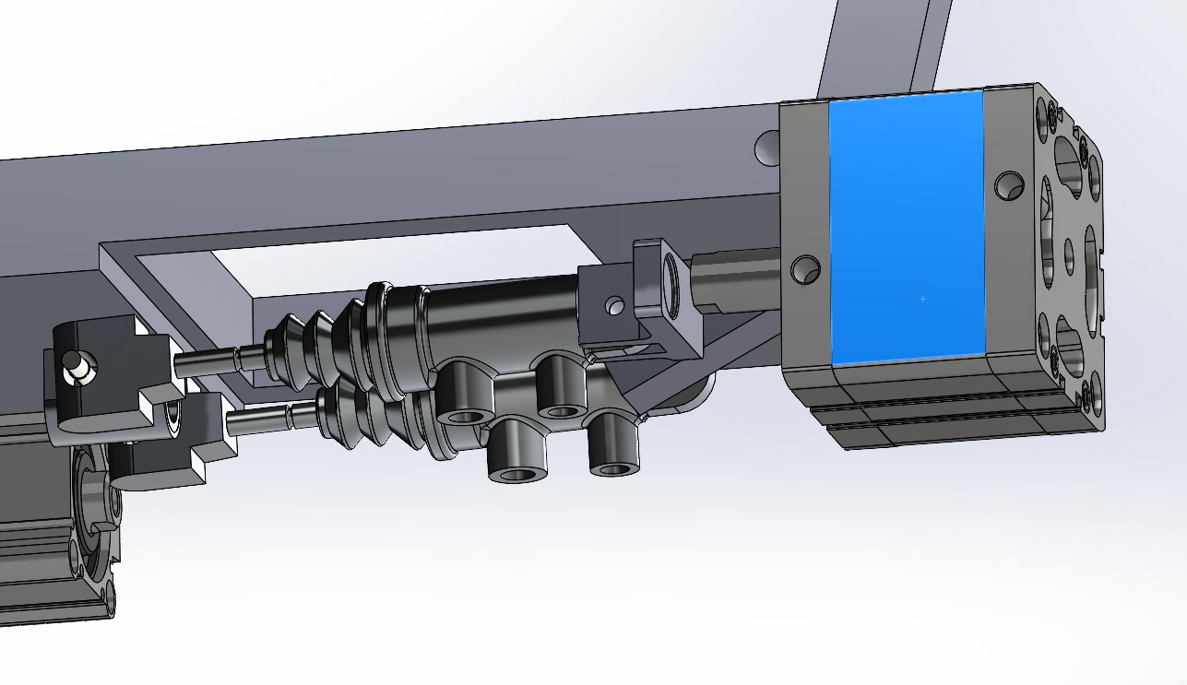

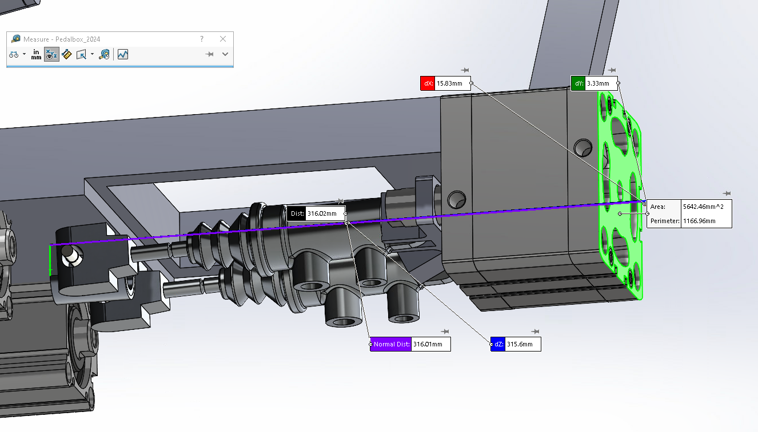

-EBS would act on the master cylinders rather than pedal

-Brings the total pedal base length to ~315mm

-Requires EBS cylinder to push rather than pull (change state of solenoid to engage?)

-Cylinders output more than required force to compress MC’s

-Packaging could be easier

-Stress analysis needs to conducted on saddle - more mounting points may be required to avoid movement on impact

Ne2 mdw nmdd

**CAD Link**

[Pedalbox 2024](https://studentutsedu-my.sharepoint.com/:f:/g/personal/cheru_dassanayake_student_uts_edu_au/ElknqJzgTsBAilfSZViQbVABgmvV4qaNEHHyRU7tJ-8Ilg?e=UNBfG6)

Updated CAD Assembly

